**Supporting information**

**Experimental Methods:** Ferrihydrite naturally exists as a hydrated mineral,1 thus it was important to prepare the mineral such that its hydration was preserved, as opposed to adding known masses of a dried sample. Here, a ferrihydrite slurry was prepared by adding 0.4 M NaOH to a 50 mM ferric chloride hexahydrate solution, and then centrifuging and washing the resulting precipitate three times with 18 MΩ water, resulting in a thick paste of ferrihydrite. A small volume (<100 mL) of DI water was added to create a slurry consistency. The iron content of the prepared ferrhydrite slurry was determined through colorimetry (ferrozine method)2 and stirred slurry aliquots were added directly to the experiments to achieve the desired mineral mass.

Goethite was prepared through slow air-oxidation of a 50 mM Fe2+ and 100 mM bicarbonate solution over two days, and then centrifuged and washed three times with 18 MΩ water. The resultant slurry was then oven dried at 70 °C for two hours, resulting in a mineral powder that was gently ground with a mortar and pestle to homogenize the sample. This dried sample was added directly to experimental bottles.

There are well established methods for preparing natural clay mineral samples for use in experimental work.3 The STx-1b montmorillonite ordered from the clays society was originally a calcium montmorillonite, but was converted to sodium montmorillonite for easier comparison to other studies. This was achieved by first dispersing the clay with 1 M NaCl, then siphoning the suspended <0.2 µm clay fraction by successively centrifuging and suspending the clay eight times in DI water. The suspension was flocculated with saturated NaCl, and excess solution removed via centrifugation. The clay suspension was then treated with a 1 M sodium acetate solution (pH 5) to remove residual carbonate minerals. The resulting Na-equilibrated montomorillonite was then centrifuged and equilibrated with the experimental background solution (10 mM NaCl), centrifuged again, dried at 70 °C overnight, and then gently powdered using mortar and pestle. This dried powder was added directly to the experiments.

All prepared minerals’ surface area was measured using a BET surface area analyzer (table S1). Ferrihydrite had to be dried for this analysis, and pyrite held anaerobically until right before analysis.

Displacement of H+ from mineral surfaces can cause sorption experiments to drift in pH over time, requiring some pH adjustment. Following the equilibration period (24 hours), pH was checked and re-titrated to the desired value if necessary; if the pH deviated more than 0.1 pH units, the bottle was allowed to re-equilibrate for 15 minutes after titration, and the re-titration process repeated. This process was sufficient to maintain the experimental pHs described.

**Analytical Methods:** Background concentrations Ra were measured on the scintillation counter to develop a limit of blank of 1.4 counts per second (cps), and activities are reported in this work only for samples that exceeded this value by a factor of 1.5. Most of the supernatant samples collected from the ferrihydrite isotherm, pH 9, did not meet this requirement, so solid associated Ra on the filtered ferrihydrite itself was counted using gamma spectroscopy. A Canberra low energy germanium detector and multichannel analyzer was calibrated using a multinuclide standard from Eckert and Ziegler ([www.ezag.com)](http://www.ezag.com)), and 226Ra activities were determined using Canberra Genie software using the 186 keV peak. The solid samples on PES filters were placed in scintillation vials, and counted directly on the counter, with the resulting counts being adjusted for ferrihydrite loss during filtration. Gamma spectroscopy was also used to quantify and confirm the 226Ra standard curve used in scintillation counting.

Table S1: Mineral BET Surface Areas

|  |  |
| --- | --- |
| **Mineral** | **Surface Area (m2/g)** |
| Ferrihydrite | 382.9 |
| Goethite | 146.46 |
| Sodium Montmorillonite | 50.162 |
| Pyrite | 0.0685 |

**Surface Complexation Modeling:** Experimental sorption data was fit only by varying radium sorption reaction constants and site densities, preferring literature values for fitted parameters as long as fits were reasonable.4,5 Surface area, while a fittable parameter in the models, was not varied, instead using the surface areas reported in table S1. Solution complexation behavior was accounted for using the SIT database, which includes radium carbonate, sulfate, chloride, and hydroxide complexes, albeit these solution complexes had little impact over the experimental conditions considered.

**Sorption Experiment Comparisons:** The literature contains a wealth of studies studying sorption through the collection of experimental isotherms. Comparison of the results in this work with those was easiest done by comparing the measured K­d, compiled in table S2. The wide variety of experimental conditions can make it difficult to understand the mechanisms controlling Ra sorption, further highlighting the need for a more mechanistic description of Ra sorption, as is provided by SCM.

Table S2: Comparison of Literature Ra Sorption Experiments and Fitted Kd Values

|  |  |  |  |  |  |
| --- | --- | --- | --- | --- | --- |
| Mineral | Solid/Solution Ratio (mg/L) | Background Solution | pH | Kd (mL/g) | Source |
| Ferrihydrite | 300 | 10 mM NaCl | 7 | 2487 | Experimental |
| 300 | 10 mM NaCl | 9 | 115900 | Experimental |
| 25000 | Seawater | 8.25 | 1535 | 6 |
| 10000 | 100 mM NaClO4 | 7 | 1440 | 5 |
| Goethite | 300 | 10 mM NaCl | 3 | 0 | Experimental |
| 300 | 10 mM NaCl | 5 | 302.7 | Experimental |
| 300 | 10 mM NaCl | 7 | 573.6 | Experimental |
| 300 | 10 mM NaCl | 9 | 11670 | Experimental |
| 25000 | Seawater | 8.25 | 20 | 6 |
| 10000 | 100 mM NaClO4 | 7 | 50.6 | 5 |
| 500000 | “pH 1 solution” | 1 | 0.752 | 7 |
| 500000 | “pH 10 solution” | 10.1 | 544 | 7 |
| Lepidocrocite | 25000 | Seawater | 8.25 | 174 | 6 |
| Hematite | 25000 | Seawater | 8.25 | 75 | 6 |
| Sodium Montmorillonite | 300 | 10 mM NaCl | 5 | 17750 | Experimental |
| 300 | 10 mM NaCl | 7 | 21470 | Experimental |
| 3333 | 10 mM NaCl | 5.25 | 9700 | 8 |
| 50000 | 10 mM NaCl | 6.5 | 3724 | 9 |

**Pyrite surface treatment:** It is difficult to explain why previous studies have not observed adsorption of Sr to a cleaned and unoxidized pyrite surface, yet we have observed measurable sorption of Ra to pyrite. Aside from the previously referenced Sr sorption modeling work, we could not find any other study that specifically examined Ra or other group II cation sorption to unoxidized pyrite surfaces. However, many have used a variety of experimental and spectroscopic techniques to study redox active metal ions sorption to the pyrite surface, which often includes redox reactions between the metal ion and pyrite surface groups.10–16 The results of these studies imply that redox active metal ions in solutions with Ra may alter the pyrite surface, consequentially blocking or enhancing Ra sorption. A notable anaerobic (O2 < 0.1 ppm) study of As3+ sorption to an oxidized synthetic pyrite surface found similarities in As3+ sorption to another study of “unoxidized” pyrite held anaerobic (O2 < 1 ppm) atmosphere.17 This suggests that pyrite typically considered unoxidized (including the pyrite surface used here) have some differences in surface chemistry compared to a “pristine” synthetic pyrite surface. These differences in pyrite treatment and cleaning during experiments could be the driver for differences in surface sites that result in this unexpected Ra sorption. Two different natural pyrites were used between the experiment here and for studying Sr sorption, thus it is also possible there are also structural differences relating to lattice substitutions of impurities or other inclusions into the pyrite.10 Only spectroscopic investigation of Ra sorption to pyrite surface, however, can elucidate the large differences between Sr and Ra sorption as well as enable the development of an SCM that accurately predicts Ra speciation in the presence of an unoxidized pyrite surface. Indeed the reactivity of the pyrite surface suggests that care must be taken to determine which surface conditions best match those found in the environment.

**Surface Complexation Modeling:**

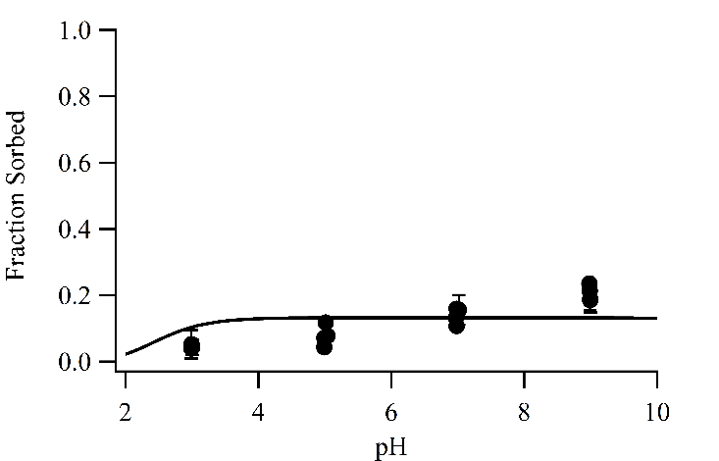 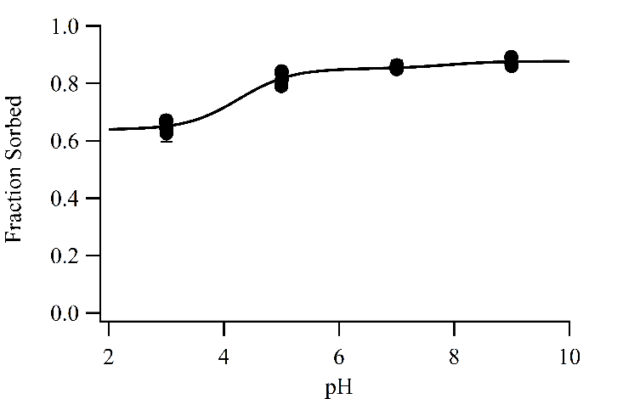Figure S1: SCM results omitted from the main text. Lines indicate model fit and points experimental data. Left: SCM of Ra sorption to Na Montmorillonite, using a 2 site reaction formulation and an exchange reaction. Right: SCM of Ra to anaerobic pyrite.

In this work, we report fitting of SCM using established reaction formulations informed by spectroscopic or *ab initio* modeling, which should be more accurate descriptions of solute sorption to a surface (Figure 2, Figure S1).18,19 There are, however, SCM formulations that are simpler, yet still provide some value; these models pose only the existence of the reaction, making no assumptions about the specific surface complexes that form, which allows for easy comparison of the relative importance of the different minerals for radium retention.20–22 These models also may provide utility in larger scale groundwater modeling efforts, as these simpler formulations are easier to add to larger scale modeling packages that incorporate a variety of biogeochemical and flow processes.

Table S3 provides the results of fitting the experimental data to these simpler reaction formulations. Ferrihydrite and goethite were fit a single site model based on a previous model of iron (hydr)oxide sorption posed by Dzombak, 1990. While that model typically specifies two sites, a strong site controlling sorption at low solute loading, and a weak site contributing to sorption at high solute loading, the model fit here only one site, exhibiting no sensitivity to a second site. The site fitted likely corresponds to the “strong” site in the Dzombak model due to the low concentration of Ra used experimentally. For sodium montmorillonite, a single site with two reactions was considered, but the fit was visually inferior to the reported two site model. The pyrite model reported here matches the model used in the main text, as both use a simple, single site model that makes no assumptions about surface reactions between Ra and pyrite. Comparing the results of the fitted reaction constants reflect experimental observations using Kd. Na-montmorillonite has the largest surface reaction constant, and the largest K­d, followed by ferrihydrite, goethite, and then pyrite.

**Table 3: SCM reaction formulas and fitted constants**

|  |  |  |  |
| --- | --- | --- | --- |
| Reactions | Sites (mol/g) | log K | Source |
| Ferrihydrite  ≡FhyOH + H+ ⇄ ≡FhyOH2+  ≡FhyOH ⇄ ≡FhyO- + H+  ≡FhyOH + Ra2+ ⇄ ≡FhyOHRa2+ | 1.87E-3 | 7.92  -8.93  5.7 | 5  20  20  Fitting |
| Goethite  ≡GoeOH + H+ ⇄ ≡GoeOH2+  ≡GoeOH ⇄ ≡GoeO- + H+  ≡GoeOH + Ra2+ ⇄ ≡GoeOHRa2+ | 3.99E-3 | 4.8  -10.4  3.5 | 23  23  23  Fitting |
| Sodium Montmorillonite  2 ≡Clay-Na + Ra2+ ⇄ ≡Clay2-Ra + 2 Na+  ≡ClayOH + H+ ⇄ ≡ClayOH2+  ≡ClayOH ⇄ ≡Clay- + H+  ≡ClayOH + Ra2+ ⇄ ≡ClayOHRa2+  ≡ClayO- + Ra2+ ⇄ ≡ClayORa+ | Surf: 3.33E-9  Exch: 8.43E-4 | 0.15  4.5  -7.9  9.8  10.1 | Fitting, clays.org CEC  Fitting  4  4  Fitting  Fitting |
| Pyrite  ≡PyrSH ⇄ ≡PyrS- + H+  ≡PyrS- + Ra2+ ⇄ ≡PyrSRa+ | 2.23E-5 | 6.45  -10.5 | 13  13  Fitting |

(1) Michel, F. M.; Ehm, L.; Antao, S. M.; Lee, P. L.; Chupas, P. J.; Liu, G.; Strongin, D. R.; Schoonen, M. a a; Phillips, B. L.; Parise, J. B. *Science* **2007**, *316* (5832), 1726–1729.

(2) Stookey, L. L. *Anal. Chem.* **1970**, *42* (7), 779–781.

(3) Klute, A.; Kunze, G. W.; Dixon, J. B. In *Methods of Soil Analysis Part 1 - Physical and Mineralogical Methods*; Soil Science Society of America, American Society of Agronomy, 1986.

(4) Bradbury, M. H.; Baeyens, B.; Geckeis, H.; Rabung, T. *Geochim. Cosmochim. Acta* **2005**, *69* (23), 5403–5412.

(5) Sajih, M.; Bryan, N. D. D.; Livens, F. R. R.; Vaughan, D. J. J.; Descostes, M.; Phrommavanh, V.; Nos, J.; Morris, K. *Geochim. Cosmochim. Acta* **2014**, *146*, 150–163.

(6) Beck, A. J.; Cochran, M. a. *Mar. Chem.* **2013**, *156*, 38–48.

(7) Nirdosh, I.; Trembley, W.; Johnson, C. *Hydrometallurgy* **1990**, *24* (2), 237–248.

(8) Tamamura, S.; Takada, T.; Tomita, J.; Nagao, S.; Fukushi, K.; Yamamoto, M. *J. Radioanal. Nucl. Chem.* **2013**, *299* (1), 569–575.

(9) Ames, L.; McGarrah, J.; Walker, B. *Clays Clay Miner.* **1983**, *31* (5), 335–342.

(10) Murphy, R.; Strongin, D. *Surf. Sci. Rep.* **2009**, *64* (1), 1–45.

(11) Kornicker, W. A.; Morse, J. W. *Geochim. Cosmochim. Acta* **1991**, *55* (8), 2159–2171.

(12) Wersin, P.; Hochella, M. F.; Persson, P.; Redden, G.; Leckie, J. O.; Harris, D. W. *Geochim. Cosmochim. Acta* **1994**, *58* (13), 2829–2843.

(13) Naveau, A.; Monteil-Rivera, F.; Dumonceau, J.; Catalette, H.; Simoni, E. *J. Colloid Interface Sci.* **2006**, *293* (1), 27–35.

(14) Naveau, A.; Monteil-Rivera, F.; Guillon, E.; Dumonceau, J. *Environ. Sci. Technol.* **2007**, *41* (15), 5376–5382.

(15) Das, D. K.; Pathak, P. N.; Kumar, S.; Manchanda, V. K. *J. Radioanal. Nucl. Chem.* **2009**, *281* (3), 449–455.

(16) Naveau, A.; Monteil-Rivera, F.; Guillon, E.; Dumonceau, J. *J. Colloid Interface Sci.* **2006**, *303* (1), 25–31.

(17) Sun, F.; Dempsey, B. A.; Osseo-Asare, K. A. *J. Colloid Interface Sci.* **2012**, *388* (1), 170–175.

(18) Fenter, P.; Cheng, L.; Rihs, S.; Machesky, M. L.; Bedzyk, M. J.; Sturchio, N. C. *J. Colloid Interface Sci.* **2000**, *225*, 154–165.

(19) Zhang, P. C.; Brady, P. V.; Arthur, S. E.; Zhou, W. Q.; Sawyer, D.; Hesterberg, D. A. *Colloids Surfaces A Physicochem. Eng. Asp.* **2001**, *190* (3), 239–249.

(20) Dzombak, D.; Morel, F. *Surface Complexation Modeling: Hydrous Ferric Oxide*; Wiley: New York, NY, 1990.

(21) Dixit, S.; Hering, J. G. *Environ. Sci. Technol.* **2003**, *37* (18), 4182–4189.

(22) Tournassat, C.; Grangeon, S.; Leroy, P.; Giffaut, E. *Am. J. Sci.* **2013**, *313* (5), 395–451.

(23) Sverjensky, D. A. *Geochim. Cosmochim. Acta* **2006**, *70* (10), 2427–2453.